**Luxury Motorcar Showcase 2022 Project**

# 1.0 Introduction and Project Background

This project is based on hosting an event that will showcase luxury motor cars. Exotic Motors is a company operating in different cities of Canada and deals with the showcase and sales of various luxury motor car models from different manufacturers. Every year, the company conducts a showcase event that includes display of new luxury car models that would soon go for sales. The event also showcases past models that the company has sold and upcoming ideas of new models that will come to the market in the near future. This year, the showcase event will be hosted in Ontario and the company has approved a project management team that will take care of the entire event including planning, execution and closing.

# 2.0 Scope and Objectives

The overall scope of the project involves hosting the showcase event at a selected location in the city. The various in-scope items for the project are listed as follows (Meredith, Shafer & Mantel Jr, 2017).

* Planning the showcase event is within the scope of the project.
* Selection of event venue is within the scope of the project.
* Contacting the car manufacturers to send their new model (upcoming releases) for showcasing is within the scope of the project.
* Marketing for the showcase event is within the scope of the project.
* Setting up the event venue is within the scope of the project.
* All arrangements and procurements for the event are within the scope of the project.
* Clearing the venue and documentation are within the scope of the project.

Based on the in-scope items and the purpose of the project, the following objectives have been developed and specified.

* To showcase upcoming new luxury car models awaiting release
* To generate interest among potential customers to purchase the cars
* To increase the current customer base of the company
* To increase the exposure of the company

# 3.0 Work Breakdown Structure

The project is broken down into individual work packages for simplification of the work required to be performed as shown in the following table (Levy, 2018).

|  |  |
| --- | --- |
| **WBS** | **Task Name** |
| **0** | **Luxury Motor Car Showcase Event** |
| **1** | **Initiation** |
| 1.1 | Board meeting |
| 1.2 | Discussion regarding project |
| 1.3 | Analyse project parameters |
| 1.4 | Finalisation of project |
| 1.5 | Milestone: Approval |
| **2** | **Planning** |
| 2.1 | Specifying scope and objectives |
| 2.2 | Specifying work packages |
| 2.3 | Finalise project timeline |
| 2.4 | Finalise project budget |
| 2.5 | Prepare mitigation plan for risks |
| 2.6 | Develop procurement plan |
| 2.7 | Milestone: Planning Complete |
| **3** | **Execution** |
| **3.1** | **Procurement** |
| 3.1.1 | Contact car manufacturers |
| 3.1.2 | Finalise showcase deals |
| 3.1.3 | Receive car shipments for showcase |
| **3.2** | **Venue** |
| 3.2.1 | Venue selection for the event |
| 3.2.2 | Getting the venue ready for hosting the event |
| 3.2.3 | Installation of stalls and other facilities |
| **3.3** | **Marketing** |
| 3.3.1 | Preparing marketing drive |
| 3.3.2 | Conduct marketing |
| **3.4** | **Event** |
| **3.4.1** | **Hosting the Event** |
| 3.4.1.1 | Presentations and Car Display Day 1 |
| 3.4.1.2 | Presentations and Car Display Day 2 |
| 3.4.1.3 | Register interest and pre-order booking |
| 3.4.2 | Milestone: Event Completed |
| **4** | **Closing** |
| 4.1 | Creating project report |
| 4.2 | Review the entire project |
| 4.3 | Stakeholder signoff |
| 4.4 | Milestone: Project marked as officially closed and complete |

The work breakdown is represented diagrammatically as shown as follows.

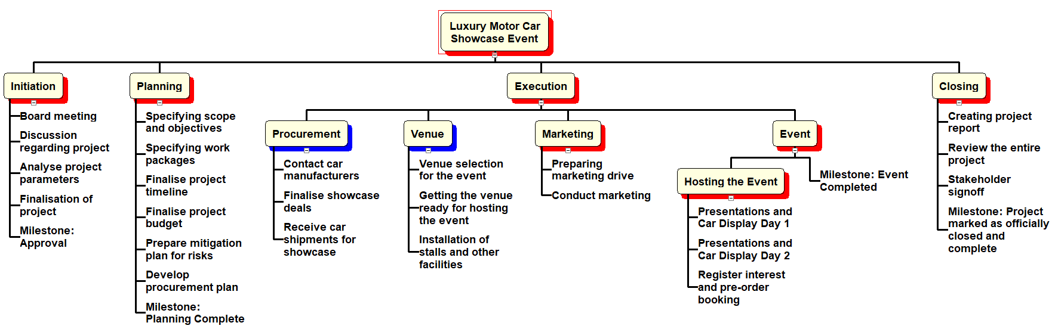

**Figure 1: Project Work Breakdown Structure**

(Source: Created by Author)

# 4.0 Project Schedule

The project schedule can be exhibited in the form of a Gantt chart that is derived from the activity list and the work breakdown structure. The project schedule is shown in the following Gantt chart (San Cristóbal et al., 2018).

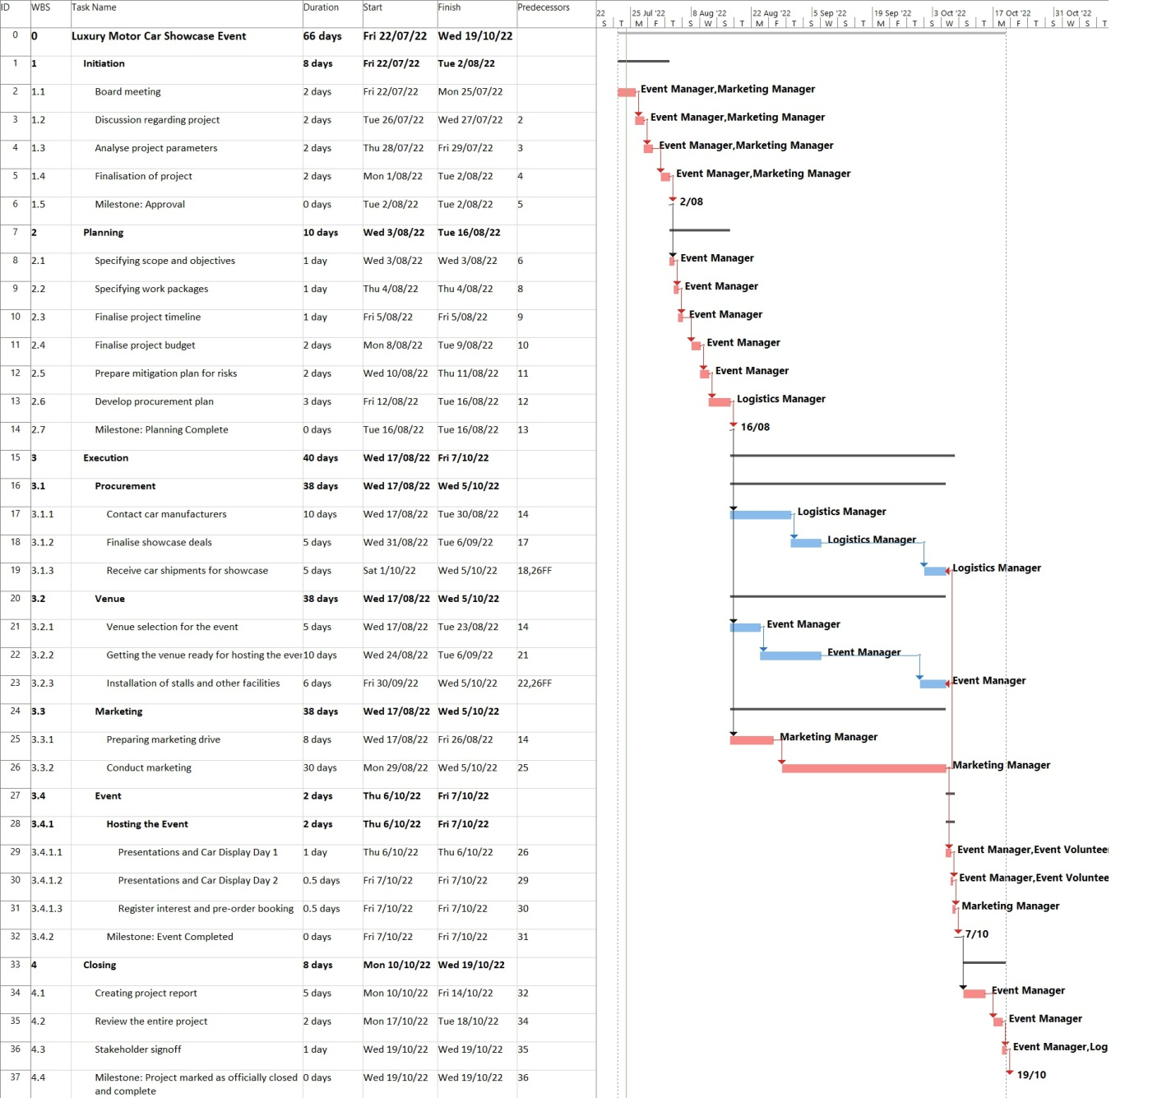

**Figure 2: Project Gantt Chart**

(Source: Created by Author)

In the above Gantt chart, it can be seen that the project is divided into several different phases – initiation, planning, execution and closing. Each of the phases has separate work packages – corresponding to the work needed to be done in the project. The execution phase has been further divided into sub-phases. Some of the activities are conducted in parallel so that the event is completely prepared before the event days. After the event is concluded and all formalities are performed, the project is officially closed after stakeholder signoffs and submission of project report document.

The schedule can be further depicted in the form of an activity on node diagram as shown as follows.

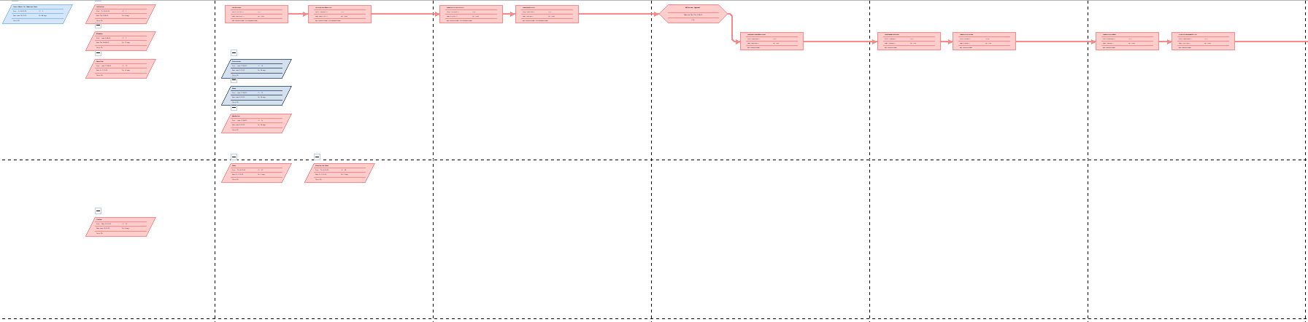

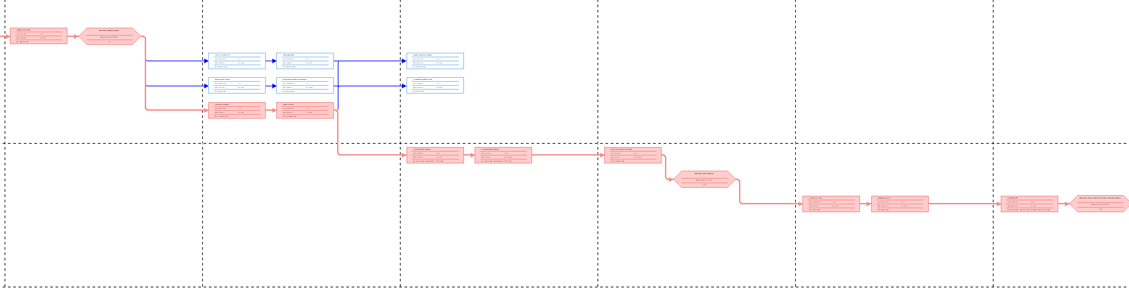

**Figure 3: Network Diagram**

(Source: Created by Author)

# 5.0 Project Budget

The project budget breakdown is shown as follows.

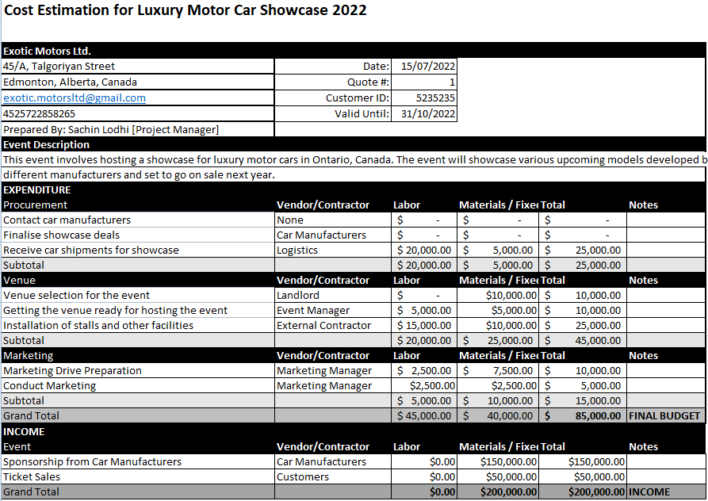

# 6.0 Risks and Mitigation

There are certain risks that may occur while the project is ongoing. Hence, it is always important to keep a mitigation plan in place after analysing the risks that may occur. The risks that can occur in this project are listed below along with their mitigation plan.

|  |  |  |  |
| --- | --- | --- | --- |
| **Risk Description** | **Probability** | **Impact** | **Mitigation** |
| The company has fixed a specific budget but unnecessary expenses and unforeseen costs can lead to over-budget issues that can create financial problems for the company (Lock, 2017). | *Medium* | *Medium* | Cost tracking at every checkpoint of the project will be necessary to ensure there are no unnecessary expenses. Cost control throughout the project should also be performed. |
| Damage to the car models during transporting from manufacturer to event venue can lead to severe loss of reputation of the company in front of the suppliers as well as potential customers. | *Medium* | *High* | Very high quality logistics services must be hired in order to ensure safety of the model vehicles. Precautions must be taken to avoid any dents or damages to the vehicles. |
| Insufficient response from the target customers can occur due to lack of marketing or other external factors like new market competitors and others (Young, 2016). | *Low* | *High* | Conduct marketing at least 2 months prior to the event so that the potential customers can have ample time to study the event details and participate in the showcase. |

# 7.0 Stakeholders and Communication Plan

As usual with any project, stakeholders will play very vital roles going forward in the project. The stakeholders associated with the project are listed below along with their roles and the communication protocol they need to follow throughout the project (Heagney, 2016).

|  |  |  |  |  |
| --- | --- | --- | --- | --- |
| **Stakeholder** | **Roles** | **Comm. Purpose** | **Comm. Frequency** | **Comm. Medium** |
| Event Manager | Managing the entire event, coordinating the teams and guiding team members are his main duties. | Coordinating information between the teams and steering committee should be done by him as per his communication duties. | Daily | Face to Face, Email |
| Logistics Manager | Managing the logistics of the luxury car models that will be showcased in the event are his main duties. | Coordinative communication between the organisation and the car manufacturers should be performed by him. | As required | Email |
| Marketing Manager | He will conduct marketing activities based on the requirements. | Establishing communication links with the target customers should be done by him as per his communication duties. | Daily | Social media posts, billboards, advertisements |
| Staff Manager | Managing team members like volunteers and other workers in the project are the parts of his responsibilities. | Communicating project requirements to the volunteers and workers should be done by him as per his communication duties. | Daily | Face to Face |

# 8.0 Quality and Procurement

In regards to quality, the project needs to fulfil certain standards and requirements. Some of the quality requirements to be fulfilled are listed as follows (Meredith, Shafer & Mantel Jr, 2017).

* The selected venue should be at a proper location in the city accessible by public and private transport.
* The event ground should have sufficient space for showcasing different brands of luxury cars.
* The cars to be showcased must be in factory condition without any damage.
* The event area should be properly arranged for the participants to check out the cars, take pictures and view presentations.

Items required to set up the event stalls should be procured from a reliable vendor after detailed background check. The luxury cars that will be showcased will have to be procured from their respective manufacturers (Heagney, 2016). The respective stakeholder will have to contact the manufacturers early and also manage logistics services to ensure the cars are properly delivered to the event ground.

# References

Heagney, J. (2016). *Fundamentals of project management*. Amacom.

Levy, S. M. (2018). *Project management in construction*. McGraw-Hill Education.

Lock, D. (2017). *The essentials of project management*. Routledge.

Meredith, J. R., Shafer, S. M., & Mantel Jr, S. J. (2017). *Project management: a strategic managerial approach*. John Wiley & Sons.

San Cristóbal, J. R., Carral, L., Diaz, E., Fraguela, J. A., & Iglesias, G. (2018). Complexity and project management: A general overview. *Complexity*, *2018*.

Young, T. L. (2016). *Successful project management*. Kogan Page Publishers.